How to Enroll in CJA Online Course
Instruction Guide

The purpose of these instructions is to guide you through enrolling in another SCCJA Online Course on South Carolina ETV’s Online Course Management site - Moodle. This is the course management system the South Carolina Criminal Justice Academy is using to host its online courses. You must already have an existing online course account in Moodle to use these instructions. If you do not already have a Moodle account, please read the “How to Set Up a NEW Online Course Account” instructions also located on CJA’s http://oneplacesc.org.
IMPORTANT! The Enrollment Key Code for each SCCJA online course is located on CJA’s OnePlaceSC page. You must have a key code to enroll in a course.

 | 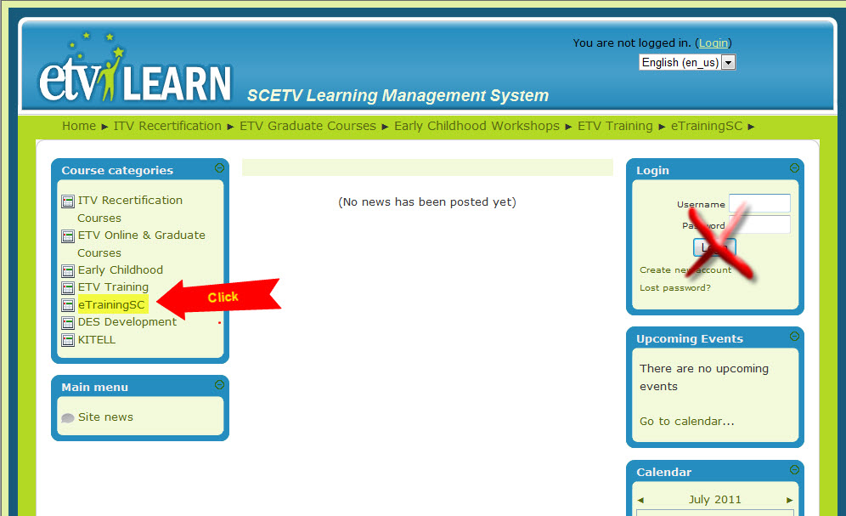  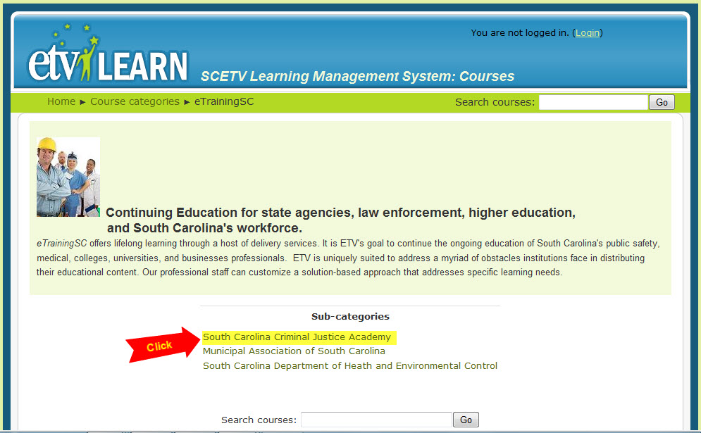 | As you have a Moodle online course account already set up, to enroll in another CJA course you simply need to access CJA’s online course site at http://moodle.scetv.org  DO NOT SIGN IN – you are prompted to sign in later in the process.  In the Course Categories block click on “eTrainingSC”  Click on “South Carolina Criminal Justice Academy” under Sub-Categories. This brings you to CJA’s course listings.
 | 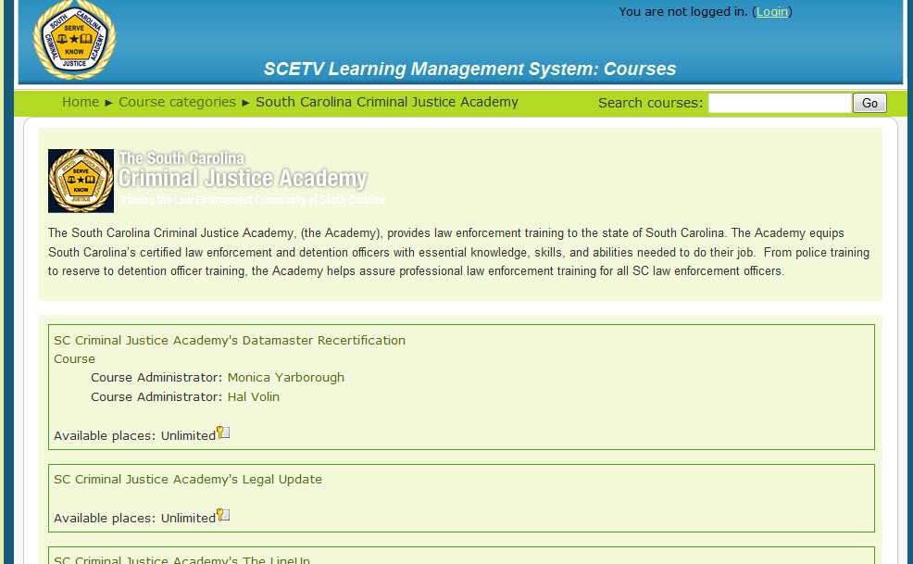 | Select the CJA course in which you want to enroll by clicking on the name of the course.
 | 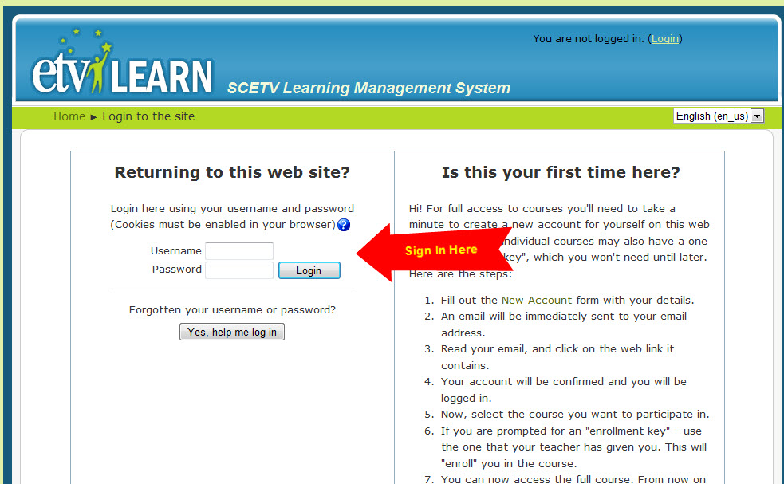 | Using your existing online course login for Moodle, sign in here.
 | 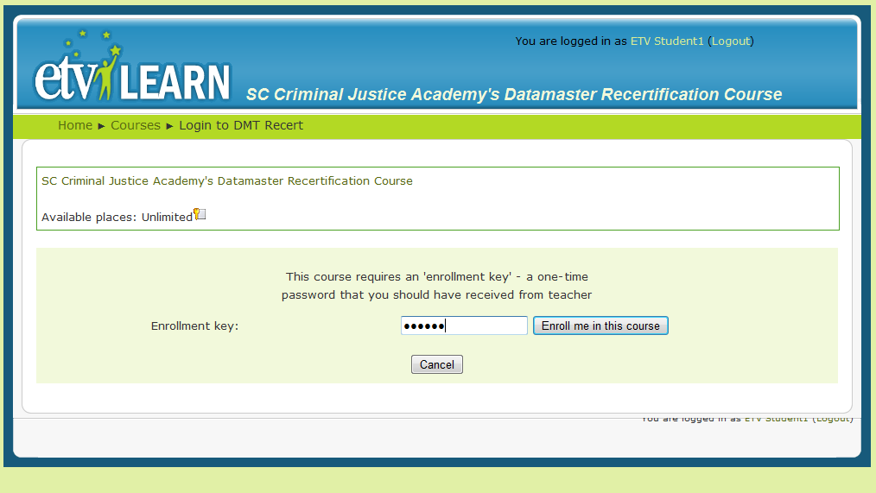  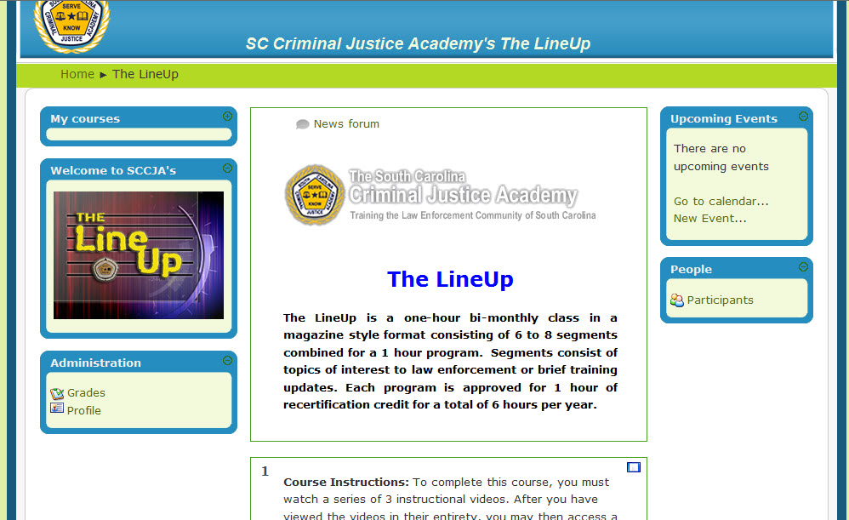 | Each CJA course has an Enrollment Key Code used to enroll into that specific course.  All of CJA’s course enrollment codes are found on http://oneplacesc.org.  This code IS case sensitive so enter the code in all caps. Enter the code for this particular course in the space provided and click “Enroll me in this course”  You are now enrolled and may begin your SCCJA course. Once you enroll in a course it is automatically listed in your personal course selections each time you log directly into Moodle.

